California Council of the Blind
2021 Virtual Conference & Convention
Sponsor and Exhibitor Packet

“BUILDING OUR FUTURE,
REMEMBERING OUR PAST”

Location
Zoom and streamed on ACB Radio
Pre-Convention
April 5 - 21, 2021
Main Event
April 22 - 25, 2021

Gabe Griffith, President
California Council of the Blind
2143 Hurley Way, Suite 250
Sacramento, CA 95825
916-441-2100
800-221-6359
SPONSORS

Gold Level

Cruise LLC
Cruise is an all-electric self-driving technology company with a mission to build the world’s most advanced autonomous vehicles (AVs) to safely connect people to the places, things and experiences they care about. For the millions of Americans who are blind or vision impaired, transportation remains a significant barrier to mobility, participation, and independence and AVs offer an incredible opportunity to change that. Cruise is building a service that can get you to your destination without you ever having to take control of the wheel.
Email: community@getcruise.com
Website: www.getcruise.com
Newsletter sign-up: https://getcruise.us20.list-manage.com/subscribe?u=f46be0762139f99fbd0d4b0c1&id=8e932c98ef
Silver Level

Energy Upgrade California
In 2020 California Council of the Blind received the 2020-21 ‘Time-of-Use’ grant from Energy Upgrade California. The ‘Time-of-Use’ project is a statewide, grassroots education and outreach campaign to encourage Californians to be mindful of energy consumption, specifically when and how. As a previous grant recipient, CCB actively engages our blind, low vision, and disenfranchised communities to provide equitable information and referrals, technical assistance, advocacy, leadership development, emergency funds, and resource-accessible technology. Energy Upgrade California’s ‘Time-of-Use’ project encourage CCB and its affiliate Californians to move from apathy to action! CCB and EUC will have an abundance of resources throughout the convention to help Keep California Golden.

Phone: (916) 441-2100
Email: info@energyupgradecacommunity.org
Website: www.energyupgradeca.org
Facebook: www.facebook.com/EnergyUpgradeCalifornia

Democracy Live
Democracy Live is the largest provider of accessible online balloting in the United States. Our OmniBallot cloud and tablet balloting tools have been deployed in over 1,500 U.S. elections and used by voters in over 90 countries. In 2020, Democracy Live was deployed in 21 states, serving voters in nearly 2,000 jurisdictions. Democracy Live also deployed a fully accessible, electronic ballot delivery and return solution in over 200 jurisdictions in the Presidential election cycle.
Phone: 1-855-655-VOTE (8683)
Email: info@democracylive.com
Website: www.democracylive.com

Vanda Pharmaceuticals - Non-24
Non-24 is a serious chronic condition that affects mainly individuals who are totally blind, but also those who are visually impaired. The three main symptoms are difficulty falling asleep, difficulty maintaining a full night's sleep and/or difficulty staying awake during the day. These symptoms are cyclical, they may come and go. If you would like to learn more and/or have your doctor educated on Non-24, please contact us.
To learn more about Non-24, please contact:
Shauna Jatho RN BSN, clinical nurse educator with Vanda
Phone: 1-202-538-0396
Email: Shauna.jatho@vandapharma.com
Website: www.non-24.com

HumanWare
HumanWare develops a range of highly intuitive solutions that empower visually impaired people by helping them to more actively participate within a sighted world. From advanced Braille products and magnifiers to digital talking book players and beyond, HumanWare’s solutions allow those with all levels of vision loss to live full and productive lives. HumanWare has recently released the new Brailliant X Series and an improved software version of the well-known Victor Reader Trek!
Phone: 1-800-722-3393
Email: info@humanware.com
Website: www.humanware.com/en-usa/home

Bronze Level

Guide Dogs for the Blind
Guide Dogs for the Blind is a compassionate community with exceptional client services and a robust network of trainers, puppy raisers, donors and volunteers. We prepare highly qualified guide dogs to serve and empower individuals who are blind or have low vision from throughout the United States and Canada. All of our services are provided free of charge, including veterinary care and extensive post-graduation support.
Contact: Jane Flower MSG
Phone: 800-295-4050 Ext. 4176
Email: jflower@guidedogs.com
Website: www.guidedogs.com
Facebook: www.facebook.com/guidedogsfortheblind
Twitter: @GDB_official
Instagram: @GDB_official
YouTube: www.youtube.com/guidedogsaregreat
LinkedIn: www.linkedin.com/company/guide-dogs-for-the-blind
Blog “No Bones About It”: www.guidedogs.com/blog

Sponsor Logos

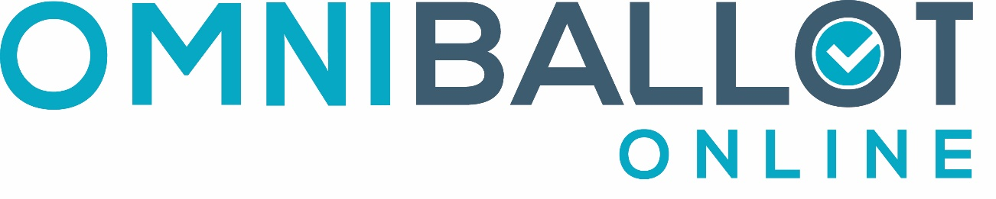

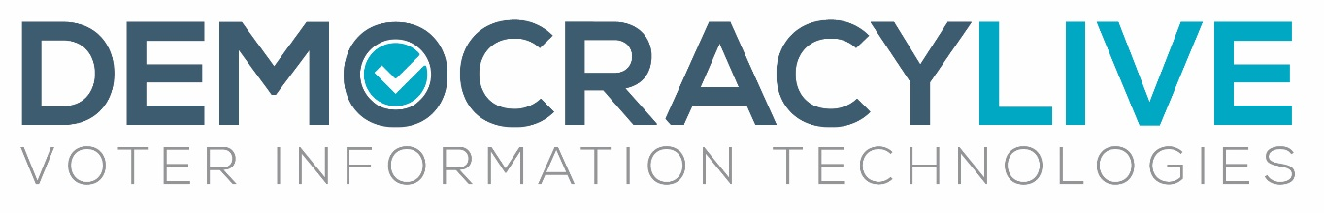

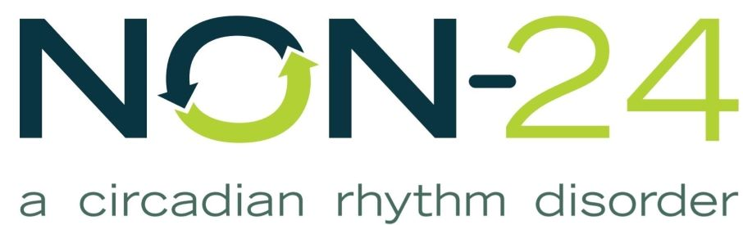

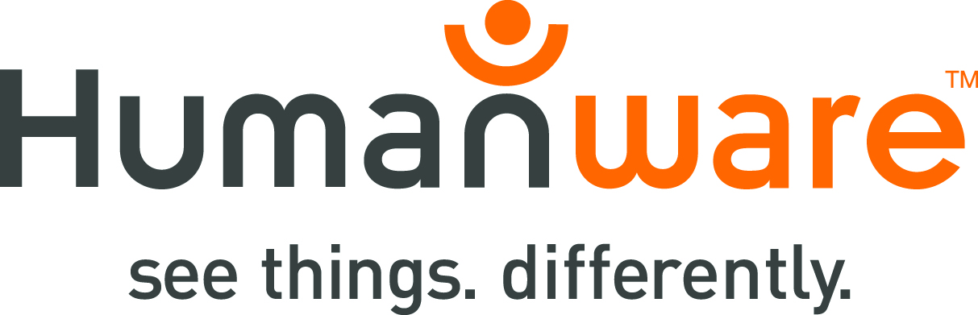

Exhibitors

Access Ingenuity
Contact: Ian Ramos
Phone: 707-579-4380
Email: ianr@accessingenuity.com
Website: www.accessingenuity.com

Anthem Blue Cross Medi-Cal
Phone: 1-800-227-3238
Website: www.anthem.com/ca/medi-cal
Facebook: www.facebook.com/AnthemBlueCrossMediCal/
Twitter: www.twitter.com/anthemBC_News

California Telephone Access Program
Contact: Michelle Gloster - Field Operations Specialist with California Phones
Phone: 951-236-3050
Contact Center Phone: 1-800-806-1191
Email: mgloster@ddtp.org
Website: www.Californiaphones.org

San Francisco Lighthouse
Phone: 415-431-1481
Email: info@lighthouse-sf.org
Website: www.lighthouse-sf.org
Facebook: www.facebook.com/lighthousesf
Twitter: www.twitter.com/lighthouse_sf
Instagram: www.instagram.com/lighthouseblind/
YouTube: www.youtube.com/channel/UC1At4KOLIcTv40Hd_UiWshQ

Victorialand Beauty
Contact: Victoria Watts, Founder/Victorialand Beauty
Email: victoria@victorialandbeauty.com
Website: www.victorialandbeauty.com
Facebook: www.facebook.com/Victorialandbeauty
Twitter: @victorialandbty
Instagram: @victorialandbeauty

Partners and Contributors

OnThe MuV® - Fundraising Partner
ACB Radio - Convention Streaming
CMAC - Video Production Services
Transcribing Mariners - Donation of Braille Program
The Braille Project - Braille Formatting
Annette Carter - Large Print Formatting
Anonymous Donor - Large Print Printing
Guillermo Robles and Steve Bauer - Audio Program

Supporters

Adaptive Technology Services
Sterling Adaptives

OnThe MuV®

You’ve patiently waited and here it is! The safe way to exercise while sitting has arrived: The electric miniTREAD® and the manual exclusive Sitmill®. With our partner Onthemuv®, these two compact and easy exercise devices provide new and accessible ways to get fit while you sit. They are now ready to order and benefit the CCB!

If you're ready to sit actively and improve your health with products that fit into your life, then the miniTREAD® and Sitmill® are for you! A portion of all sales go towards further sustaining CCB’s service, educational, and advocacy endeavors.

We're happy to help! Call us at 510-629-1276 to order your miniTREAD® or Sitmill®.
Email: onthemuv@ccbnet.org.

